Pet Ad posting screen.

Workshop #01

Flutter Developer Bootcamp

# **Purpose**

This workshop demonstrates how to create a pet Ad posting screen.

# **Problem**

You're updating a Pet Seller App with new features:

1. Gender Selection: Add a way for sellers to choose the gender of the pet (Male/Female).
2. Vaccination Status: Include a checkbox for sellers to indicate if the pet is vaccinated.
3. Age Slider: Implement a slider for sellers to set the age of the pet.

# **How to Solve**

1. Checkout the workshop from Git Repo:

git clone -b <user-branch> <repo-URL>

2. Open the root folder inside VS Code

3. To build the app click the run option in the main method { }

4. Create a radio button , checkbox and slider to finish the workshop

# **You Will Achieve**

In this workshop, you will learn how to use Flutter to create a pet selling screen. You will explore widget composition, layout, handling user input with text fields, dropdowns, radio buttons, checkboxes, and sliders. This exercise introduces them to building interactive UIs in Flutter.

# **Screenshots**

## **Before implementation (without Radio button , Checkbox & Slider)**

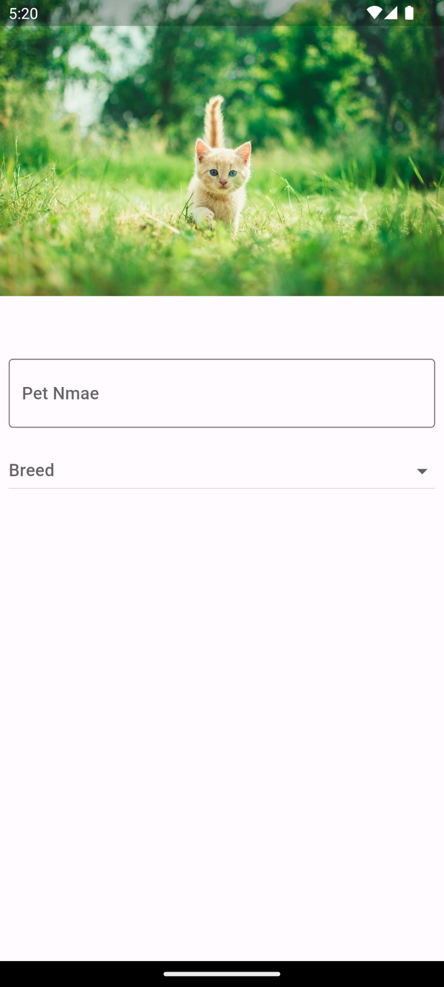

## **After implementation (With Radio button , Checkbox & Slider)**

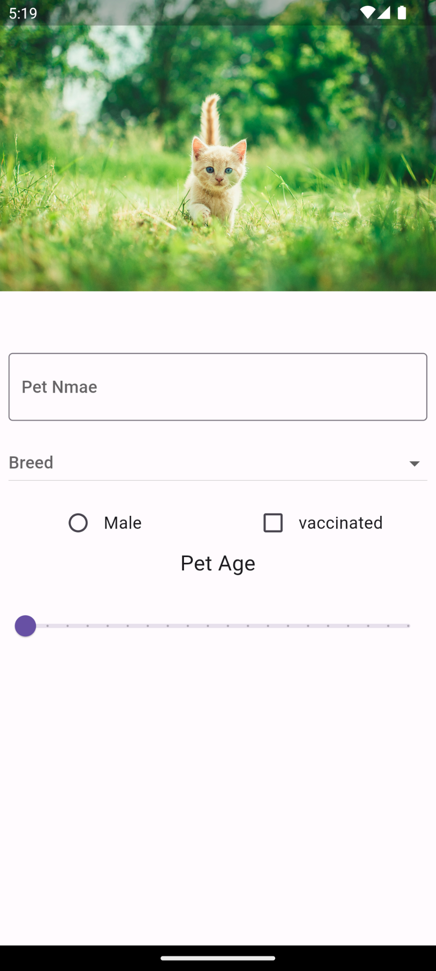

# **How to submit your workshop**

Push your project back to the same git branch using command:

<command name>

# **Happy Coding!**